How do I read the Meet announcement?
To access a meet announcement, you will need to log onto the club website, again select “meet/event registration”
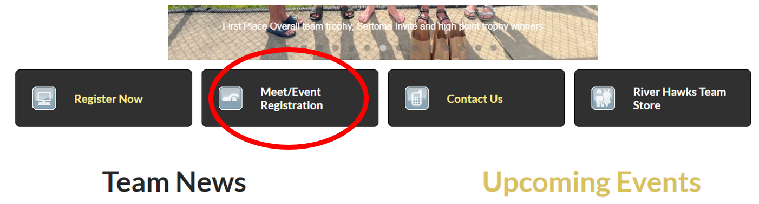
Next select team events. Click on the name of the event you wish to view

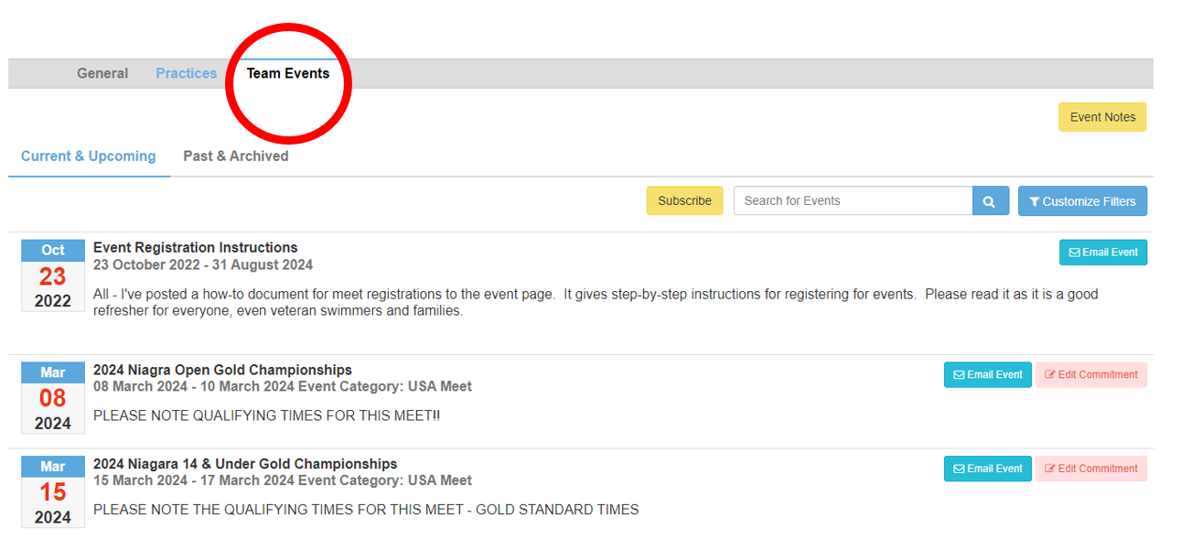
The event details will open. Under the “Forms/Documents” label the “meet announcement” will be posted. Select the meet announcement.
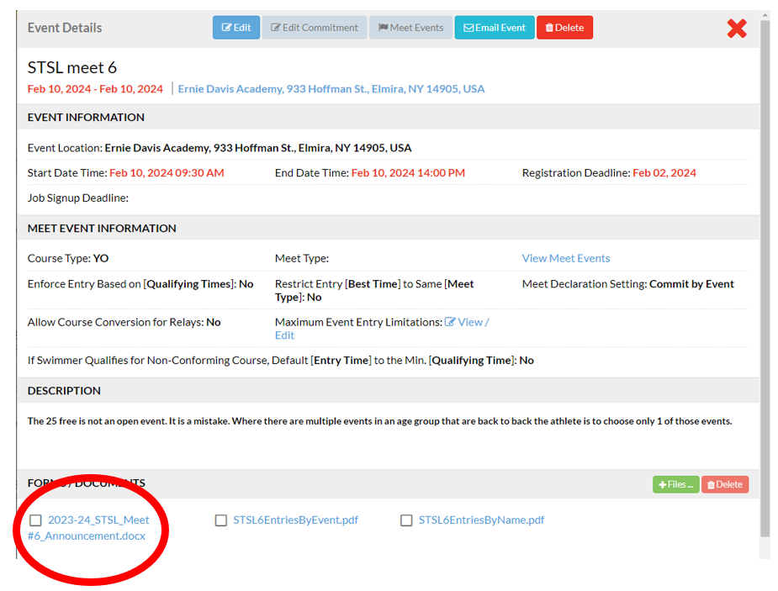

The meet announcement is a several page document. At the top of the page will have the meet name and date, the host club, the name of the meet director and meet referee. There is detailed information about the facility (address, information about the pool, etc).

There is information regarding entry deadline. PLEASE NOTE THE ENTRY DEADLINE WILL BE LATER THAN THE DEADLINE WE POST ON THE WEBSITE, THIS GIVENS THE TEAM TIME TO RECEIVE ENTRIES, MAKE RELAY TEAMS, AND REVIEW SWIMMERS REGISTRATIONS FOR THE EVENTS. AGAIN PLEASE BE COGNIZATION OF THE DEADLINE POSTED ON THE WEBSITE, THIS IS NONNEGOTIABLE AND IF YOU DO NOT REGISTER YOUR SWIMMER BEFORE THE DEADLINE LISTED ON THE CLUB EVENT POSTING YOUR SWIMMER WILL NOT BE ABLE TO PARTICIPATE IN THE MEET!!!
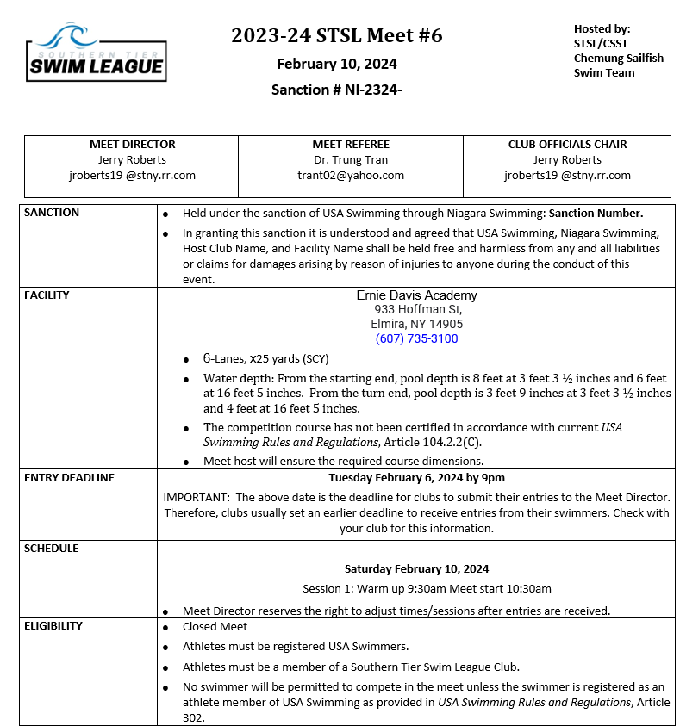
Under the “entry deadline” you will see “schedule”. This will tell you what time your swimmer should arrive for warm-ups and what time the meet starts. It is VERY important your swimmer arrives ON TIME for warm ups.

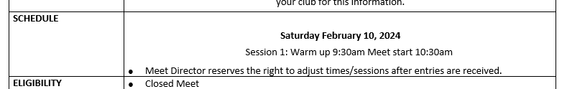

You will find infomration regarding how the meet will be scored. If there will be awards given at the meet. Infomration regarding whether there will be programs for sale at the meet (sometimes the programs can be printed prior to the meet from the host club’s website.). There is also information regarding whether or not there is a fee for spectators.
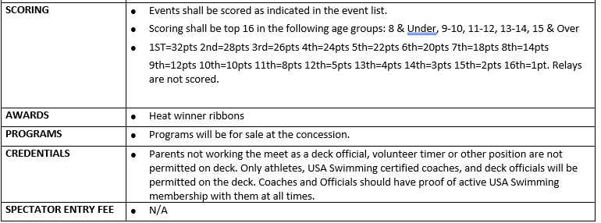

There is info regarding entry fees. You will be billed by the club AFTER the meet, please note if you register your swimmer for the meet but you do not attend YOU WILL STILL BE BILLED. Changes to meet commitment CANNOT be made after the deadline. Again if you sign your swimmer up but do not attend the meet you will still be billed for your swimmer’s entry fee.

Very important in the meet announcement is entry limits. For this particular meet swimmers can be entered in up to 3 individual events and 1 relay.
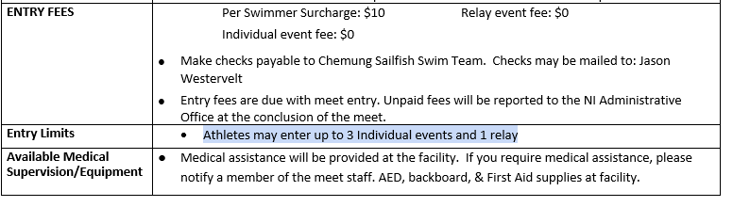

You will also find the event list, this is helpful so you know what event your swimmer will swim. It can also be helpful if you want to make sure your swimmer does not swim back to back events.
